HANOI UNIVERSITY OF SCIENCE AND TECHNOLOGY

**SCHOOL OF ELECTRICAL AND ELECTRONIC ENGINEERING**



**PROJECT REPORT**

**Self-produced movie with VFX**

Name of students: *Class code : 152564 – Team 12*

Pham Huy Hoang – 20233850

Bui Thai Son – 20233874

Le Duy Duc – 20233838

Name of instructor: Dr. Pham Van Tien

Hà Nội, 1/2025

Table of Contents

List of Tables v

ACKNOWLEDGEMENT vi

ABSTRACT vii

1. Introduction 1

1.1. Motivation 1

1.2. Objectives 1

1.2.1. Main objectives 1

1.2.2. Specific objectives 2

2. Methodology 2

2.1. State of the art 2

2.1.1. Methods for VFX 2

2.1.2. Existing products for VFX 2

2.1.3. Discussions 2

3. Project implementation 3

3.1. Step 1: User requirements 3

3.2. Step 2: Specifications 5

3.3. Step 3: Planning 5

3.4. Step 4: Block Design 6

3.5. Step 5: Protyping 6

3.5.1. Simulation 6

3.5.2. Produce the prototype 6

4. Discussions 6

5. Conclusions and future works 7

# List of Figures

Figure 1.1: Objective of the project 1

Figure 3.1: Planning of the project 5

# List of Tables

Table 2.1: Comparision of existing products 2

Table 3.1: Summary of existing systems 5

Table 3.3: Summary of task distrubution and completeness 5

# ACKNOWLEDGEMENT

In the current era of information explosion, the potential for growth and innovation in advertising is immense, making the application of new techniques increasingly essential in this field.

We extend our heartfelt gratitude to Dr. Pham Van Tien for his invaluable support and for providing the necessary conditions that enabled our team to complete this project successfully.

Despite our best efforts, we acknowledge the limitations of our abilities. As this project represents a new domain for our team, some design errors in content and presentation methods may have occurred. We sincerely welcome Dr. Pham Van Tien's guidance and your constructive feedback to help us refine and improve this work.

Finally, we would like to express our deep appreciation to everyone who contributed to the completion of this project.

# ABSTRACT

This report explores the integration of fictitious characters and advanced visual effects to enhance storytelling in digital media and cinematic productions. By analyzing the use of techniques such as matte painting, motion capture, and particle systems, it examines how these methods contribute to creating immersive environments and lifelike characters. The study also highlights the creative and technical processes involved in incorporating fictitious entities into narratives, offering insights into character design, animation workflows, and post-production enhancements. The findings underscore the importance of blending artistic vision with technological innovation to push the boundaries of visual storytelling. This report aims to provide an overview of current practices and inspire future advancements in the field of visual effects and digital character creation.

# Introduction

## Motivation

This project represents an exciting opportunity to blend creativity and innovation in storytelling. By producing a movie independently and integrating visual effects (VFX), the project leads us to new field of work.

Taking full control of the filmmaking process allows for the expression of an unfiltered creative vision. It’s a journey of skill development, as mastering VFX tools enhances both technical and artistic capabilities. This project serves the viewer, creating the myterious and make them curiousity like a real trailer.

## Objectives

### Main objectives

* Know how to design and create a short movie with the help of VFX (blender)

Make a short movie

Composition

VFX

Motion-tracking

Figure .: objective of the project

### Specific objectives

* Specific objectives 1: design a scene using motion tracking in order to mixing two virtual environments and real environments
* Specific objectives 2: create the virtual environment using Blender
* Specific objectives 3: using video editior software to edit all the objectives 1 and 2

# Methodology

## State of the art

### Methods for VFX

* 3D tracking and creating model
* Compositing
* Lighting

### Existing products for VFX

Table .: Comparision of existing products

|  |  |  |  |
| --- | --- | --- | --- |
| Product | Main features | Advantages | Drawbacks |
| P1 | Iron man 1 VFX | Epic scope and scale | Inconsistance quality |
| P2 | Godzilla minus one | Visually stuning | Some small scene look fake |
| P3 | Morbius VFX | No pros | Expensive |

### Discussions

* **Balancing Scale and Quality**:  
  While Marvel movies have large scale in the market, but the quality is not as good as the money they spend. Otherwise, Godzilla minus one with a small budget, they can still manage a good quality.
* **Opportunities for Innovation**:

Addressing animation consistency in Godzilla minus one VFX could make it a contender for a wider range of projects.

Improving Marvel’s workflows and supporting VFX teams can sustain their dominance.

* Reducing cost barriers, as seen in Morbius, might democratize access to high-quality VFX for smaller studios.

# Project implementation

## Step 1: User requirements

* **Methods**

**Interviews**

* + **Purpose**: Gather detailed insights from filmmakers, VFX artists, and project managers.
  + **Focus**: Understand the challenges, tools, workflows, and preferences in VFX production for short films.
  + **Questions**:
    - What are the biggest challenges in creating VFX for short movies?
    - Which tools and software do you find essential or lacking?
    - How do budget and time constraints impact your work?

**Observations**

* + **Purpose**: Observe real-world workflows and problem-solving techniques in VFX production.
  + **Focus**: Identify inefficiencies, bottlenecks, and best practices in the pipeline.
  + **Example Observations**:
    - Time taken for rendering.
    - Collaboration between teams (e.g., director and VFX artist).
    - Usage of resources (hardware, software, manpower).

**Questionnaires**

* + **Purpose**: Collect quantitative data on the experiences and opinions of a larger group of professionals.
  + **Focus**: Gain insights into software preferences, common limitations, and user satisfaction.
  + **Sample Questions**:
    - Rate the importance of the following tools in your VFX process (1-5 scale).
    - What percentage of your budget is typically allocated to VFX?
    - Which aspect of VFX production causes the most delays?

Table .: Summary of existing systems

|  |  |  |  |
| --- | --- | --- | --- |
| **Model** | **Specification** | **Advantage** | **Drawback** |
| **Endgame VFX** | Large-scale CGI, interconnected universe | Epic scope and cohesive visuals | Inconsistent quality at times |
| **Godzilla minus one VFX** | Artistic and stylized VFX | Visually stunning and creative | Limited realism, animation inconsistencies |
| **Morbius VFX** | Realistic and dark CGI environments | High-end execution | Expensive, limited accessibility |

# 

## Step 2: Specifications

* Render time: 1 frame per 2 minutes

## Step 3: Planning

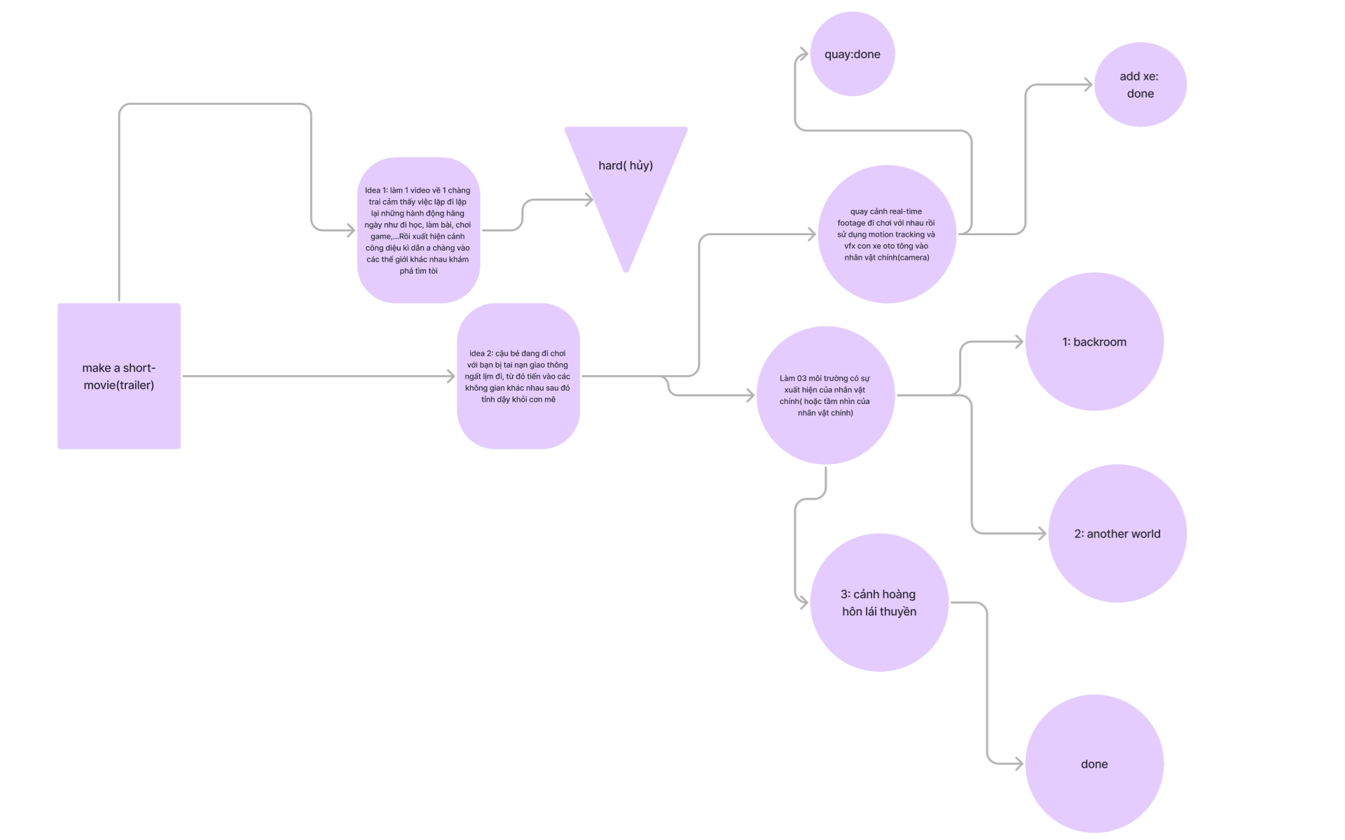

Figure .: Planning of the project

Table .: Summary of task distrubution and completeness

|  |  |  |
| --- | --- | --- |
| Member | Tasks | Completeness |
| Bùi Thái Sơn | Tạo thế giới (1) Tìm kiếm resource pack Test các hiệu ứng và truyền đạt lại Máy chủ render (1) Xử lý các lỗi xảy ra với các thành viên | 85% |
| Phạm Huy Hoàng | Tạo các model cần thiết Xây dựng thế giới (2) Viết báo cáo và thuyết trình Chịu trách nhiệm quản lý các thành viên | 80% |
| Lê Duy Đức | Tạo thế giới (3) Xử lý các hiệu ứng hậu kỳ Tổng hợp tư liệu từ các thành viên Dựng slide thuyết trình Máy chủ render (2) | 85% |

## Step 4: Block Design

## Step 5: Protyping

### Simulation

### Produce the prototype

* Present the process and the result (final product)

# Discussions

Creating a self-produced movie with VFX offers an exciting opportunity for creative storytelling but comes with notable challenges. The freedom to control the entire production process allows filmmakers to bring their unique vision to life without the constraints of external studios. Modern VFX tools like Blender, After Effects, and Unreal Engine have made high-quality effects more accessible, enabling independent creators to achieve professional results on limited budgets.

However, self-production also requires balancing ambition with practicality. VFX work demands significant technical skills, including 3D modeling, animation, and compositing, which can be overwhelming for a small team or an individual. Budget constraints often limit access to high-performance hardware, professional software, or render farms, making resource management critical. Time constraints further complicate the process, as rendering and iterative improvements can significantly extend production schedules.

To succeed, careful planning is essential. Pre-visualizations and storyboards can help streamline the workflow and ensure that VFX elements align with the story’s needs. By focusing on achievable goals and leveraging online resources for skill development, independent filmmakers can create impactful visual effects that enhance their movies without overextending their resources.

# Conclusions and future works

The self-produced movie with VFX successfully met its objectives by combining creative storytelling with effective visual effects. The project achieved seamless VFX integration and established a practical workflow, enhancing the film’s overall impact.

However, challenges such as limited resources and hardware constraints affected the complexity of the effects. These limitations suggest opportunities for improvement.

Future work could explore cloud-based rendering to address hardware issues and use AI tools to simplify workflows. Experimenting with more advanced VFX and collaborating with experts from different fields could further elevate the quality of future projects.